Face Diagonal

Definition
# Source: AI Source: Provided by: [Data Path: Persons Table -> ID Column: 1, Name_En Column: Motasem Essam] -> From: [ChatGPT] on [7/25/2026]
A face diagonal of a cube is a line segment connecting two opposite vertices of the same square face.
It lies entirely on one of the cube's six square faces and divides that face into two congruent right-angled isosceles triangles.
Because every face of a cube is a square with equal side lengths, all face diagonals have the same length.
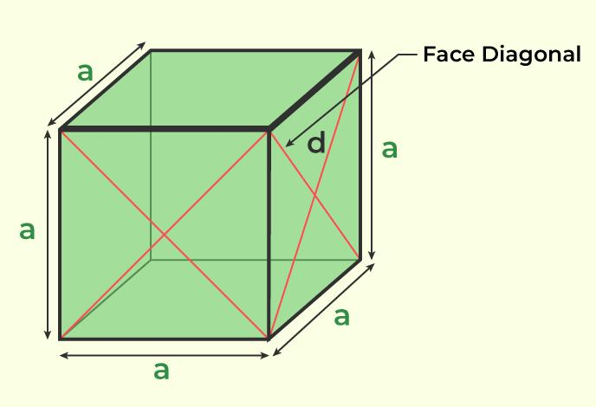

Geometric Structure
# Source: AI Source: Provided by: [Data Path: Persons Table -> ID Column: 1, Name_En Column: Motasem Essam] -> From: [ChatGPT] on [7/25/2026]
A cube has the following face diagonal characteristics:
- Location: Each face diagonal lies on one of the six square faces.
- Endpoints: It connects two opposite vertices of the same face.
- Shape: It divides a square face into two congruent right triangles.
- Length: Every face diagonal has an equal length.
- Quantity: Each square face has two face diagonals.

Number of Face Diagonals
# Source: AI Source: Provided by: [Data Path: Persons Table -> ID Column: 1, Name_En Column: Motasem Essam] -> From: [ChatGPT] on [7/25/2026]
A cube has six square faces, and each square contains two diagonals.
$$N_{f}=6×2$$
$$\boxed{N_{f}=12}$$
Therefore, a cube has 12 face diagonals.

Mathematical Properties
# Source: AI Source: Provided by: [Data Path: Persons Table -> ID Column: 1, Name_En Column: Motasem Essam] -> From: [ChatGPT] on [7/25/2026]
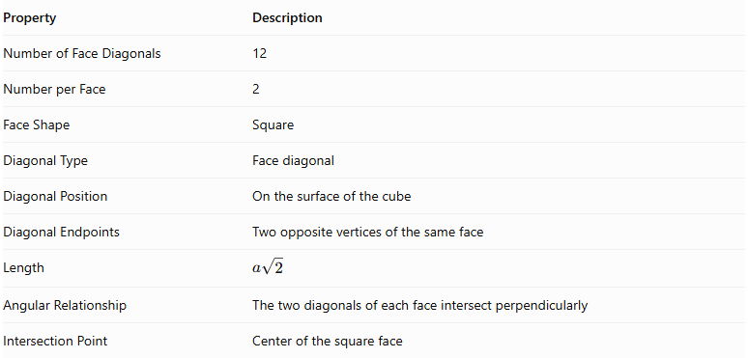
Property | Description
Number of Face Diagonals | 12
Number per Face | 2
Face Shape | Square
Diagonal Type | Face diagonal
Diagonal Position | On the surface of the cube
Diagonal Endpoints | Two opposite vertices of the same face
Length | $$a\sqrt{2}$$
Angular Relationship | The two diagonals of each face intersect perpendicularly
Intersection Point | Center of the square face

Face Diagonal Formula
# Source: AI Source: Provided by: [Data Path: Persons Table -> ID Column: 1, Name_En Column: Motasem Essam] -> From: [ChatGPT] on [7/25/2026]
The face diagonal is calculated using the Pythagorean theorem, because each square face forms a right triangle when divided by its diagonal.
Let:
- $a$ = Edge length of the cube.
- $d_{f}$ = Face diagonal length.
Applying the Pythagorean theorem:
$$d_{f}^{2}=a^{2}+a^{2}$$
$$d_{f}^{2}=2a^{2}$$
Taking the square root:
$$\boxed{d_{f}=a\sqrt{2}}$$

Alternative Formula
# Source: AI Source: Provided by: [Data Path: Persons Table -> ID Column: 1, Name_En Column: Motasem Essam] -> From: [ChatGPT] on [7/25/2026]
If the face diagonal is known, the edge length can be calculated as:
$$\boxed{a=\frac{d_{f}}{\sqrt{2}}}$$

Approximate Value
# Source: AI Source: Provided by: [Data Path: Persons Table -> ID Column: 1, Name_En Column: Motasem Essam] -> From: [ChatGPT] on [7/25/2026]
$$\sqrt{2}≈1.41421356$$
Therefore:
$$d_{f}≈1.4142a$$
The face diagonal is approximately 1.4142 times the cube's edge length.

Geometric Relationships

Relationship with the Face Edges
# Source: AI Source: Provided by: [Data Path: Persons Table -> ID Column: 1, Name_En Column: Motasem Essam] -> From: [ChatGPT] on [7/25/2026]
Each face diagonal connects two opposite vertices of a square face.
$$d_{f}=a\sqrt{2}$$

Relationship with the Space Diagonal
# Source: AI Source: Provided by: [Data Path: Persons Table -> ID Column: 1, Name_En Column: Motasem Essam] -> From: [ChatGPT] on [7/25/2026]
The space diagonal connects two opposite vertices of the cube through its interior.
$$d_{s}=a\sqrt{3}$$
The relationship between the two diagonals is:
$$d_{s}^{2}=d_{f}^{2}+a^{2}$$
Therefore:
$$\boxed{d_{s}=\sqrt{d_{f}^{2}+a^{2}}}$$
Since:
$$\sqrt{3}>\sqrt{2}$$
The space diagonal is longer than the face diagonal.

Relationship with the Face Area
# Source: AI Source: Provided by: [Data Path: Persons Table -> ID Column: 1, Name_En Column: Motasem Essam] -> From: [ChatGPT] on [7/25/2026]
The area of one square face is:
$$A_{f}=a^{2}$$
Since:
$$d_{f}=a\sqrt{2}$$
Then:
$$\boxed{A_{f}=\frac{d_{f}^{2}}{2}}$$

Relationship with the Face Perimeter
# Source: AI Source: Provided by: [Data Path: Persons Table -> ID Column: 1, Name_En Column: Motasem Essam] -> From: [ChatGPT] on [7/25/2026]
The perimeter of one square face is:
$$P_{f}=4a$$
Using the face diagonal:
$$\boxed{P_{f}=2\sqrt{2} d_{f}}$$

Worked Examples
# Source: AI Source: Provided by: [Data Path: Persons Table -> ID Column: 1, Name_En Column: Motasem Essam] -> From: [ChatGPT] on [7/25/2026]
Example 1: Calculate the face diagonal of a cube with an edge length of 5 cm.
Given:
$$a=5\text{ cm}$$
Formula:
$$d_{f}=a\sqrt{2}$$
Substitution:
$$d_{f}=5\sqrt{2}$$
$$\boxed{d_{f}≈7.071\text{ cm}}$$
Example 2: Calculate the edge length of a cube whose face diagonal is 10 cm.
Given:
$$d_{f}=10\text{ cm}$$
Formula:
$$a=\frac{d_{f}}{\sqrt{2}}$$
Substitution:
$$a=\frac{10}{\sqrt{2}}$$
$$\boxed{a=5\sqrt{2}≈7.071\text{ cm}}$$

Comparison with Space Diagonal
# Source: AI Source: Provided by: [Data Path: Persons Table -> ID Column: 1, Name_En Column: Motasem Essam] -> From: [ChatGPT] on [7/25/2026]
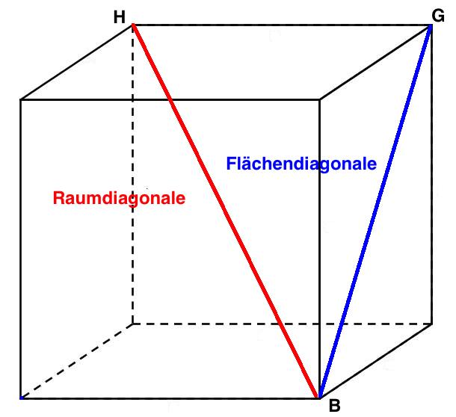
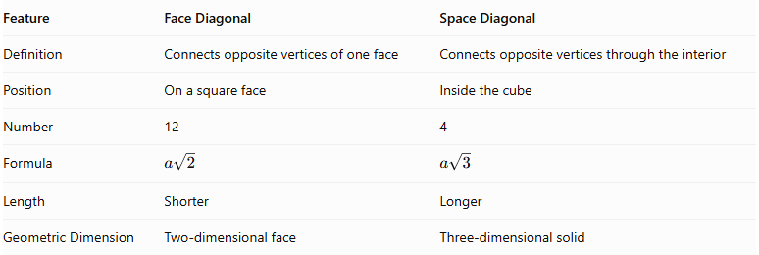
Feature | Face Diagonal | Space Diagonal
Definition | Connects opposite vertices of one face | Connects opposite vertices through the interior
Position | On a square face | Inside the cube
Number | 12 | 4
Formula | $$a\sqrt{2}$$ | $$a\sqrt{3}$$
Length | Shorter | Longer
Geometric Dimension | Two-dimensional face | Three-dimensional solid

Main Classification
# Source: AI Source: Provided by: [Data Path: Persons Table -> ID Column: 1, Name_En Column: Motasem Essam] -> From: [ChatGPT] on [7/25/2026]
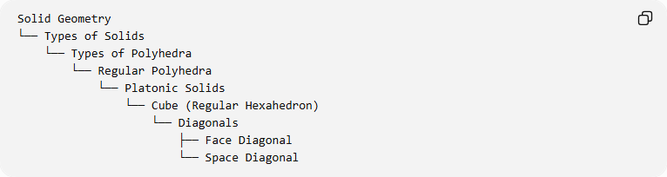
Solid Geometry
└── Types of Solids
└── Types of Polyhedra
└── Regular Polyhedra
└── Platonic Solids
└── Cube (Regular Hexahedron)
└── Diagonals
├── Face Diagonal
└── Space Diagonal

Key Points
# Source: AI Source: Provided by: [Data Path: Persons Table -> ID Column: 1, Name_En Column: Motasem Essam] -> From: [ChatGPT] on [7/25/2026]
- A face diagonal connects two opposite vertices of the same square face.
- Each square face has two face diagonals.
- A cube has 12 face diagonals in total.
- All 12 face diagonals have equal lengths.
- The face diagonal formula is $d_{f}=a\sqrt{2}$.
- Each face diagonal divides its square face into two congruent right triangles.
- A face diagonal is shorter than the cube's space diagonal.

Conclusion
# Source: AI Source: Provided by: [Data Path: Persons Table -> ID Column: 1, Name_En Column: Motasem Essam] -> From: [ChatGPT] on [7/25/2026]
The Face Diagonal is an important geometric element of a cube (Regular Hexahedron). It connects opposite vertices on a square face, has a length of $a\sqrt{2}$, and occurs twice on each of the cube's six faces, giving a total of 12 face diagonals.

